esure

**Test Plan – ES Motor Q&B, All Devices Test Name: Add on Comparison Tables**

Author: Rosie Enoch

23/07/2021

|  |  |  |
| --- | --- | --- |
| Name | Version | Changes |
| Consultant name | 1 | Document created |
|  |  |  |
|  |  |  |

**Jira Ticket Number**

OT-276

**Test Background**

Evidence

We know that comparison tables provide a clear visual to inform users of what the product includes. We also know it isn’t clear on our Q&B journey what the key differences are between core cover and additional cover. We are designing a comparison table for every add on, comparing it to the cover in the core policy to increase add on uptake.

Hypothesis

By creating a comparison table for each add on, we will increase clarity & value proposition therefore, increase add on uptake & ASR-Per-Sale.

Test Goal

Add on Uptake %

**Targeting**

|  |  |  |
| --- | --- | --- |
| **Name** | **Description** | **Example URLs** |
| Optional Extras – ES Motor Q&B | The Add ons step on motor Q&B PCW journey | <https://www.esure.com/motor/cover-options> |

**Audiences**

Devices

Desktop, Tablet, Mobile

Other

Exclude internal Ips

Out of Global Holdback

Optimizely project number/name

ES - QnB – Motor

**Scenarios & Considerations**

Scenarios

* When I user lands on the optional Extras Page, they will be presented with the first add on (Motor Legal Protection as per control) this will be in the form of a comparison table.
* If User Selects ‘Yes, add add for ‘£xx’ in the Motor Legal Protection table then the product is added, the column highlights and they are scrolled to the next add on (Car Hire).
* If a User selects ‘No, continue without Car Hire then the product is not added, the column highlights and they are scrolled to the next add on (Car Hire).
* If User Selects ‘Yes, add add for ‘£xx’ in the Car Hire table then the product is added, the column highlights and they are scrolled to the next add on (Personal Injury Benefit).
* If a User selects ‘No, continue without Car Hire then the product is not added, the column highlights and they are scrolled to the next add on (Personal Injury Benefit).
* If User Selects ‘Yes, add add for ‘£xx’ in the Personal Injury Benefit table then the product is added, the column highlights and they are scrolled to the next add on (Key Cover).
* If a User selects ‘No, continue without Personal Injury Benefit then the product is not added, the column highlights and they are scrolled to the next add on (Key Cover).
* If User Selects ‘Yes, add add for ‘£xx’ in the Key Cover table then the product is added, the column highlights and they are scrolled to the next add on (PNCD).
* If a User selects ‘No, continue without Key Cover then the product is not added, the column highlights and they are scrolled to the next add on (PNCD).

Considerations

* **No changes have been made to PNCD, this should work as control**
* **Functionality of scrolling to next add on should be same as control**
* **All tables should be visible (greyed out) when a user first lands on the page as per control.**

**Variations**

Control – Desktop Variation – Desktop (not selected & selected)

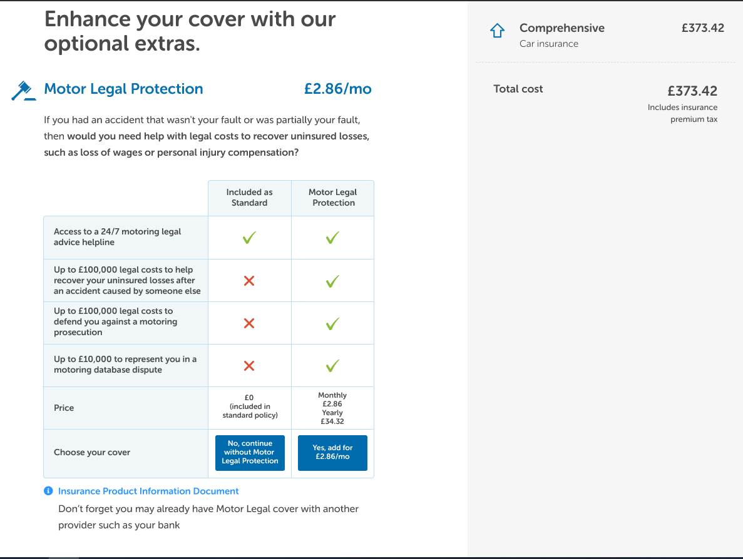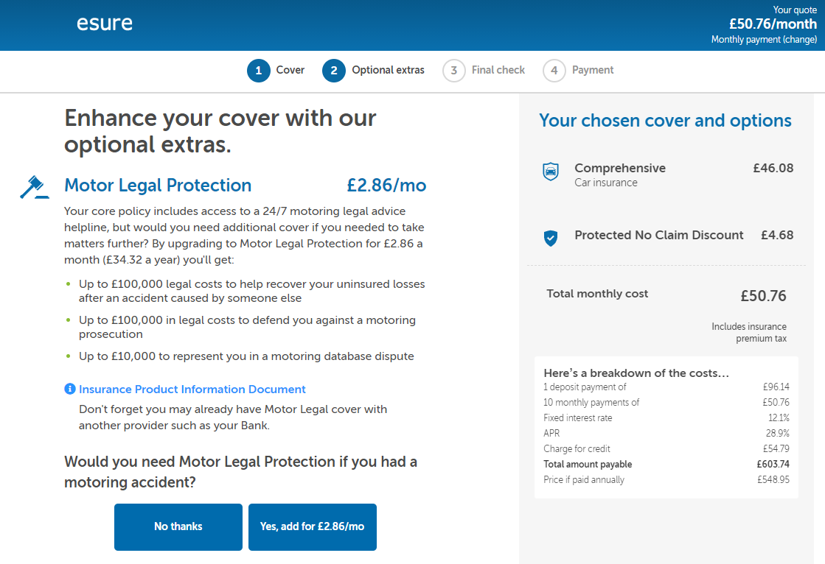

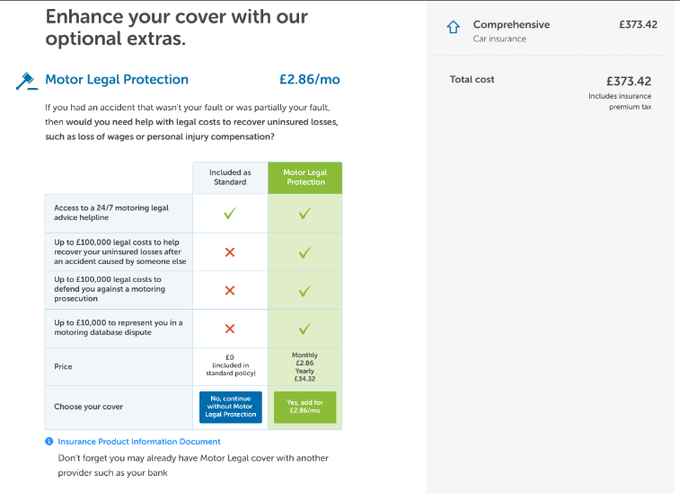

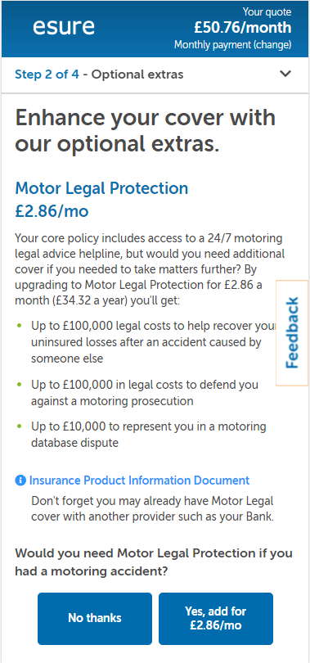Control – Mobile Variation – Mobile (selected state)

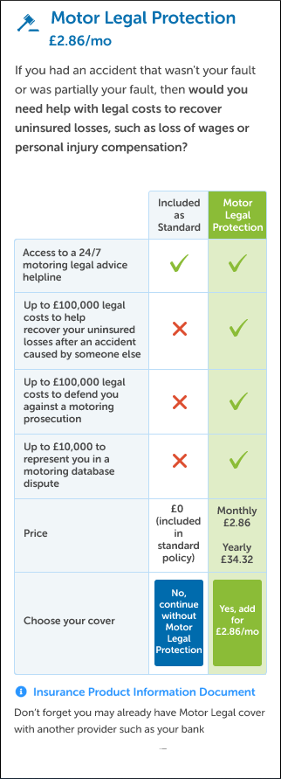

Design changes

* Comparison table for each individual add on comparing additional cover to standard policy cover.

Link to Designs

Mobile:

﻿

﻿Desktop: ﻿[https://www.figma.com/proto/OruubBOFliZb8o15jKnsMz/%5BDesign-Changes%5D-Esure%3A-Motor%3A-Add-Ons-Co...](https://www.figma.com/proto/OruubBOFliZb8o15jKnsMz/%5BDesign-Changes%5D-Esure%3A-Motor%3A-Add-Ons-Comparison-Table-Format%3A-All-Devices?page-id=0%3A1&node-id=4%3A2&viewport=241%2C48%2C0.03&scaling=min-zoom&starting-point-node-id=4%3A2&show-proto-sidebar=1)﻿

﻿

﻿Mobile: ﻿[https://www.figma.com/proto/OruubBOFliZb8o15jKnsMz/%5BDesign-Changes%5D-Esure%3A-Motor%3A-Add-Ons-Co...](https://www.figma.com/proto/OruubBOFliZb8o15jKnsMz/%5BDesign-Changes%5D-Esure%3A-Motor%3A-Add-Ons-Comparison-Table-Format%3A-All-Devices?page-id=0%3A1&node-id=152%3A7298&viewport=241%2C48%2C0.03&scaling=min-zoom&starting-point-node-id=152%3A7298&show-proto-sidebar=1)

**Metrics**

|  |  |
| --- | --- |
| **Name** | **Description** |
| NEW: Clicks on ‘Continue without Motor Legal Protection’ | Button clicks on the table for no don’t add product MLP |
| NEW: Clicks on ‘Yes, add for £xx/mo’ (MLP) | Button clicks on the table for yes add product MLP |
| NEW: Clicks on ‘Continue without Car Hire’ | Button clicks on the table for no don’t add product Care Hire |
| NEW: Clicks on ‘Yes, add for £xx/mo’ (Car Hire) | Button clicks on the table for yes add product Car Hire |
| NEW: Clicks on ‘Continue without Personal injury Benefit’ | Button clicks on the table for no don’t add product PIB |
| NEW: Clicks on ‘Yes, add for £xx/mo’ (PIB) | Button clicks on the table for yes add product PIB |
| NEW: Clicks on ‘Continue without Key Cover’ | Button clicks on the table for no don’t add product Key Cover |
| NEW: Clicks on ‘Yes, add for £xx/mo’ (Key Cover) | Button clicks on the table for yes add product Key Cover |
| Sales: Overall Addons | Add on Sales Conversion Rate |
| Sales: Car Hire | Car Hire Sales Conversion Rate |
| Sales: MLP | MLP Sales Conversion Rate |
| Sales: Personal Injury | PIB Sales Conversion Rate |
| Sales: Key Cover | Key Cover Sales Conversion Rate |
| Sales: NCD Protection | PNCD Sales Conversion Rate |
| Sales: Breakdown | Breakdown Sales Conversion Rate |
| Sales: Road and Recovery (BK5) | lowest tier sales for breakdown |
| Sales: Road (BK1) | Highest tier sales for breakdown |
| Sales: Road (BK3) | Highest tier sales for breakdown |
| Visited Page: Confirmation page | Purchase Conversion Rate |
| Visited Breakdown Page: All page page | Breakdown Page Step Conversion Rate |
| Visited Page: Final Check (Review) page | Final Check Step Conversion Rate |

**Segments**

|  |  |
| --- | --- |
| **Name** | **Values description** |
| Aggregator | “agg” or “not_agg” depending on whether or not the user comes via an aggregator |
| Time of day | “morning”, “evening” or “afternoon” depending on what time of day the user comes to the funnel |

**Integrations**

|  |  |
| --- | --- |
| **Name** | **Values description** |
| Adobe Analytics | eVar138 |

**QA Tier completed by esure**

QA Tier to be carried out by esure (see tier overview below)

What Devices / Browsers have passed QA?

e.g: Safari desktop

**QA Tier to be carried out by REO**

Tier Number 1 & 2 (TBC)

(Only QA additional devices / browsers not covered in esure QA)

Please note specific devices/browsers in QA tier to be validated in QA:

e.g iphone 5

**QA Tiers for reference**

